Draft Guidance Document  
Preparation of the Product Monograph in Extensible Markup Language (XML) Format

This guidance document is being distributed for comment purposes only.

Draft date YYYY-MM-DD

|  |  |  |  |
| --- | --- | --- | --- |
| **Revision Number** | **Date** | **Author(s)** | **Brief Description of Changes** |
| 1.0 | October 29, 2021 | Tracy Brown | Creation of document. Two prior drafts were amalgamated. |
| 1.01 | November 18, 2021 | Tracy Brown | Revised based on comments. |
| 1.02 | December 14, 2021 | Tracy Brown | Revised based on comments. |
| 1.03 | April 20, 2022 | Tracy Brown | Revised based on comments from the Industry working group. |
|  |  |  |  |

Health Canada is responsible for helping Canadians maintain and improve their health. It ensures that high-quality health services are accessible, and works to reduce health risks.

Également disponible en français sous le titre :  
XXXXXXXXXXXXXXXXXXXXXXXX

To obtain additional information, please contact:

Health Canada  
Address Locator 0900C2  
Ottawa, ON K1A 0K9  
Tel.: 613-957-2991  
Toll free: 1-866-225-0709  
Fax: 613-941-5366  
TTY: 1-800-465-7735  
E-mail: [publications-publications@hc-sc.gc.ca](mailto:publications-publications@hc-sc.gc.ca)

© His Majesty the King in Right of Canada, as represented by the Minister of Health, 20XX

Publication date: Month 20XX

This publication may be reproduced for personal or internal use only without permission provided the source is fully acknowledged.

# Foreword

Guidance documents are meant to provide assistance to industry and health care professionals on **how** to comply with governing statutes and regulations. Guidance documents also provide assistance to staff on how Health Canada mandates and objectives should be implemented in a manner that is fair, consistent, and effective.

Guidance documents are administrative instruments not having force of law and, as such, allow for flexibility in approach. Alternate approaches to the principles and practices described in this document ***may be*** acceptable provided they are supported by adequate justification. Alternate approaches should be discussed in advance with the relevant programme area to avoid the possible finding that applicable statutory or regulatory requirements have not been met.

As a corollary to the above, it is equally important to note that Health Canada reserves the right to request information or material, or define conditions not specifically described in this document, in order to allow the Department to adequately assess the safety, efficacy, or quality of a therapeutic product. Health Canada is committed to ensuring that such requests are justifiable and that decisions are clearly documented.

This document should be read in conjunction with the accompanying notice and the relevant sections of other applicable Guidance documents.

# Table of contents

Foreword 4

Table of contents 5

1. Introduction 7

1.1 Purpose/Overview 7

1.2 Scope and application 7

1.3 Policy Objectives 7

1.4 Policy Statements 7

1.5 Background 7

2. Guidance for Creating the XML PM 8

2.1 Overview 8

2.2 Controlled Vocabulary 8

2.2.1 Controlled Vocabulary Listing Website 10

2.2.2 Missing or Unknown Terms 10

2.2.3 Status of Controlled Vocabulary 10

2.3 High-Level XML Structure and Document Set-Up 11

2.4 Organization Details 12

2.4.1 Product Details 13

2.4.2 Manufactured Product 14

2.4.3 Ingredients 14

2.4.4 Packaging Status 18

2.4.5 Product Status 20

2.4.6 Product Characteristics 21

2.4.7 Route of Administration 23

2.4.8 Multi-Part Products 23

2.5 Product Monograph Content 25

2.5.1 Title Page 27

2.5.2 Notice of Compliance with Conditions and Biosimilar Biologic Drug 29

2.5.3 Recent Major Label Changes 30

2.5.4 Part 1: Health Professional Information and Part II: Scientific Information 31

2.5.5 Patient Medication Information 32

2.6 Additional Concepts 33

2.6.1 Format 33

2.6.2 Images 33

2.6.3 Tables 34

2.6.4 Hyperlinks 36

2.6.5 Boxes statements 37

2.6.6 Footnotes 38

2.6.7 Special Characters 39

2.7 Relationship of Unique Identifiers 39

3. Validation 41

4. Guidance for Submitting the XML PM 41

4.2 Setting up the XML PM in an eCTD sequence 43

Appendices 44

Appendix A – Acronyms 44

Appendix B - Terms 45

Appendix C – Process Flows 47

# Introduction

## Purpose/Overview

The purpose of this guidance is to assist sponsors in developing a product monograph in the Extensible Markup Language format (XML PM).

## Scope and application

The scope of this guidance and the use of the XML format for PMs is limited to the following product lines:

* Pharmaceutical drugs for Human Use
* Biologic drugs for Human Use
* Radiopharmaceuticals

The following product lines are out of scope:

* Pharmaceutical drugs for Human Use - Non-prescription
* Self-care products
* Natural health products
* Medical devices
* Veterinary drugs
* Food

## Policy Objectives

* The objective of this document is to provide operational direction and guidance to sponsors and Health Canada staff on the requirements for the preparation of the XML PM.

## Policy Statements

* This guidance document applies to the preparation and filing of XML PMs and should be read in conjunction with the following:
* XML PM Samples
* Validation rules for Product Monographs in the Extensible Markup Language (XML) format
* Controlled Vocabulary List
* Guidance Document: Product Monograph
* Product Monograph Master Template
* Guidance Document: Preparation of Drug Regulatory Activities in the Electronic Common Technical Document Format
* Questions and Answers: Plain Language Labelling Regulations for Prescription Drugs – document

## Background

The PM provides the necessary information for the safe and effective use of a drug product. It is comprised of three major sections, two of which target health care professionals. The third section targets the consumer. The PM is submitted by sponsors for review in a MSWord format. Once approved, the document is converted to PDF and published to the DPD Online.

The XML PM represents a major step towards Health Canada’s goal of improving access to drug information for Canadians.  The structure and controlled vocabulary will enable benefits not previously possible - consistency, searchability and innovation. Approved XML PMs will be stored in a fully searchable XML database. Stylesheets will enable transformation into a human readable format. This format will enable the appropriate data to be provided in ways that are most relevant to different user groups, including providing Canadian pharmacies reliable access to the Canadian approved Patient Medicinal Information. It will also facilitate further collaboration with our international partners related to drug clinical trials, risk assessments and potential shortages.

# Guidance for Creating the XML PM

## Overview

This document is the technical implementation for Product Monographs (PM) in the XML format, known as the XML PM. A supporting XML PM Sample is available as both an HTML rendering and in XML code (.xml file).

All guidance for the PM content is provided in the *Product Monograph Guidance Document*, except for the Product Details which is only found in the XML PM. The PM content should be aligned with the information provided in the Product Details section. This means that the same terms should be used, however more narrative context may be permitted in the PM content.

Information that is required in the final XML PM but unknown at the time of filing should be left blank (e.g., control number). Placeholder or dummy data (e.g., TBD or Unknown) should not be used.

Many images in this document are screenshots of the rendered HTML, the XML code or both. These images are intended to show specific technical details for creating a valid XML PM. All of these images have been taken from the accompanying XML PM sample, with the exception of Figure 39 and Figure 40.

## Controlled Vocabulary

A Controlled Vocabulary (CV) is an established list of pre-approved terms and ensures that a subject will be described using consistent terms. HC has developed the [Controlled Vocabulary List](https://cv.hres.ca/) to support the XML PM, primarily based on the international standards. For example, Health Level Seven (HL7), International Organization for Standardization’s (ISO) and the Identification of Medicinal Products (IDMP). Where an international standard does not exist, the CV has been based standards set by other regulators (e.g., Food and Drug Administration (FDA)) or are Health Canada (HC) specific.

Sponsors are required to author the XML PM using the associated CV to ensure consistent and standardized content. Terms support English and French XML PMs and are case sensitive. The expectation is that the same code will be used for both languages with only the display names changing.

**Table 1 Codes, Display Name and Source of Terms in the Controlled Vocabulary List**

| **OID / Code** | **Display Name (EN)** | **Source** |
| --- | --- | --- |
| 2.16.840.1.113883.2.20.6.10 | DOCUMENT TYPE | HPFB |
| 2.16.840.1.113883.2.20.6.14 | INGREDIENT IDENTIFIER | FDA |
| 2.16.840.1.113883.2.20.6.15 | UNITS OF MEASURE | UCUM |
| 2.16.840.1.113883.2.20.6.17 | COUNTRY CODE | ISO |
| 2.16.840.1.113883.2.20.6.2 | SCHEDULE | HPFB |
| 2.16.840.1.113883.2.20.6.23 | PRODUCT CHARACTERISTICS | HPFB |
| 2.16.840.1.113883.2.20.6.24 | COLOUR | FDA |
| 2.16.840.1.113883.2.20.6.25 | SHAPE | FDA |
| 2.16.840.1.113883.2.20.6.26 | FLAVOUR | FDA |
| 2.16.840.1.113883.2.20.6.29 | LANGUAGE CODE | HPFB |
| 2.16.840.1.113883.2.20.6.3 | DOSAGE FORMS | DPD |
| 2.16.840.1.113883.2.20.6.31 | COMPANY IDENTIFIER | DPD |
| 2.16.840.1.113883.2.20.6.32 | PACKAGE TYPE | EDQM |
| 2.16.840.1.113883.2.20.6.37 | REGULATORY ACTIVITY | HPFB |
| 2.16.840.1.113883.2.20.6.39 | INGREDIENT ROLE | HL7 |
| 2.16.840.1.113883.2.20.6.4 | SCORE | HPFB |
| 2.16.840.1.113883.2.20.6.5 | PHARMACEUTICAL STANDARD | DPD |
| 2.16.840.1.113883.2.20.6.53 | PRODUCT TYPE | HPFB |
| 2.16.840.1.113883.2.20.6.6 | THERAPEUTIC CLASS | WHO |
| 2.16.840.1.113883.2.20.6.63 | MASTER TEMPLATE | HPFB |
| 2.16.840.1.113883.2.20.6.65 | STYLE SHEET VERSION | HPFB |
| 2.16.840.1.113883.2.20.6.7 | ROUTE OF ADMINISTRATION | EDQM |

The following provides additional information on specific CVs.

**Ingredient Identifier (6.14)**

Health Canada’s list of ingredients is based on the [Global Substance Registration System (GSRS)](https://precision.fda.gov/uniisearch) and the Unique Ingredient Identifier (UNII). The HC CV is a subset of that list and will include ingredients used in Canadian products. The display names are the Canadian preferred terms based on pre-established criteria and are linked to the UNII through the list of synonyms.

**HC Ingredient CV = FDA UNII + HC preferred term**

The GSRS allows for the searching of an ingredient that returns potential matches and synonyms. All ingredients (active or inactive) used in products regulated by the US FDA are available in GSRS. It may be necessary to consult chemistry and manufacturing experts to determine the correct UNII. Please refer to Figure 52 in Appendix C for the suggested process flow.

If no acceptable UNII is found, the sponsor is required to provide sufficient scientific information to support a request for a new UNII.

**Company Identifier (6.31)**

The Company ID is a unique 5-digit code that is assigned the first time a company submits information to Health Canada related to human drugs, biologics and radiopharmaceuticals.

**Package Type (6.32) and Route of Administration (6.7)**

These two lists are sourced from the European Directorate for the Quality of Medicines and HealthCare (EDQM). When selecting EDQM sourced terms, the definitions available in the [Standard Term database](https://standardterms.edqm.eu/)[1] should be considered.

**Therapeutic Class (6.6)**

This list is sourced from the [WHO’s ATC Index](https://www.whocc.no/atc_ddd_index/). The ATC classification system is a hierarchy with 5 different levels, with 14 different groups at the highest level. The therapeutic classification to be included in the Product Details section of the XML PM should be at the lowest possible level. Therefore, only codes from the 4th and 5th levels are included in HCs Therapeutic Class CV listing.

The therapeutic classification level in the Product Details section may be more granular from that included on the Title Page but should be in the same hierarchy. To decrease confusion, only the text of the classification should appear on the title page, and only the code will appear in the Product Details section.

### Controlled Vocabulary Listing Website

The CV website compliant with Web Content Accessibility Guidelines 2.0 (WCAG 2.0), bilingual, and provides the ability to search online or by downloading in either XML or Comma Separated Value (CSV) format. Each list and term will include the code, English display name, French display name, source, status and date it was last updated.

Sponsors can use the filter items field to search within a CV for a term or code. Each column can also be sorted.

**Figure 1 Screenshot from the Controlled Vocabulary Listing website**

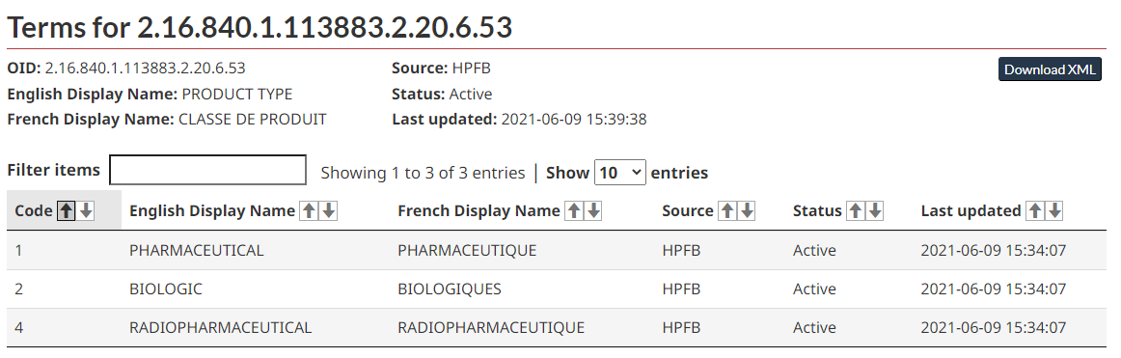

### Missing or Unknown Terms

Contact the XML PM team via [email](mailto:xmlpm-pmxml@hc-sc.gc.ca) if:

* If your Company ID is not listed or the name has changed
* You can find an ingredient UNII on GSRS but not in the CV listing
* The ACT code is not in the CV listing
* When the French term is not listed

### Status of Controlled Vocabulary

All CVs are assigned a status against which they are validated as outlined in the table below. This includes both the vocabularies (e.g., OID 2.16.840.1.113883.2.20.6.10 / DOCUMENT TYPE) and the vocabulary related terms (e.g., code 4 / MASTER TEMPLATE).

**Table 2 Definition of Controlled Vocabulary Status and Corresponding Validation Message**

|  |  |  |
| --- | --- | --- |
| **Status** | **Definition** | **Validation** |
| Active | Available for use. Expected most of the time | Pass |
| Inactive | Only for use under specific circumstances.  For example, an XML PM using the 2016 template (OID 6.60) cannot convert to the master template during an Administrative Regulatory Activity (RA) for a company name change. In this case, the inactive term must be used until an appropriate RA is submitted. | Warning |
| Temporary | Under review by HC. Not permitted for final version.  For example, if a sponsor proposes a new ingredient (e.g., XYZ). An initial analysis shows that XYZ does not have a UNII code (GSRS). HC would assign a temporary code while the term was reviewed. By the end of the review process, one of two things will happen.   1. XYZ was determined to be a new ingredient and the status will be changed to active. 2. XYZ was determined to be the synonym for ABC and the status will be changed to deprecated.   Company must request temporary terms from HC prior to submission. | Warning |
| Deprecated | Created in error and should not be used. | Error |

## High-Level XML Structure and Document Set-Up

**XML Structure**

The figure below is representative of the overall XML PM structure. This includes the prolog, document metadata, organization metadata and the content. Each of these will be further elaborated upon below.

**Figure 2 High-Level Structure shown in XML Code**

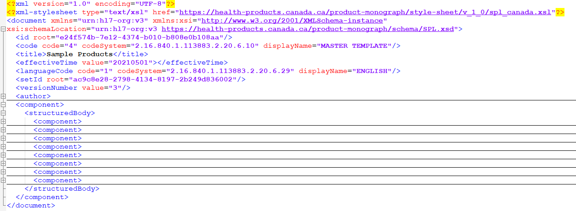

The first four lines in the image above identifies the XML version, character encoding, and the reference to the locations of the schema and style sheet. The stylesheet URL includes a version number (e.g., v_1_0). This version number is selected from the CV (OID 6.65).

**Document ID (<id>)**

The document ID is the unique identifier for this instance of the XML PM. The .xml file name needs to match the document ID, which is a Globally Unique Identifier (GUID). The expectation is that this will change every time the XML PM is provided in a regulatory transaction.

**Document type (<code>)**

The code and display name for the PM template are selected from the CV (OID 6.10).

**Document title (<title>)**

The document title should be reflective of all products captured by the XML PM. The format of the title should be BRAND NAME (common proper name), DOSAGE FORM, as outlined in the PM Guidance. The title should only be 1 line and images are not to be included.

**Document Date (<effectiveTime>)**

This is a sponsor-defined value. The date format is YYYYMMDD.

**Document Language (<languageCode>)**

The code and display name for the language of the document are selected from the CV (OID 6.29).

**Document File Name (<setID>)**

The Set ID is the unique identifier that remains the same for all instances for a single language of the XML PM. The set id is a GUID.

**Document Version (<versionNumber>)**

This is a sponsor-defined value; however, it must be a whole number that does not contain letters, symbols or decimals.

## Organization Details

The organization details identify the Market Authorization Holder and Importer / Distributor of the product.

**Figure 3 Company Details Section Shown in the Rendered HTML and the Supporting XML Code**

**Time (<time>)**

No information is required and is an empty element.

**Market Authorization Holder (<representedOrganization>)**

The Market Authorization Holder (MAH) is the legal entity that holds the Notice of Compliance and the Drug Identification Number (DIN).

**Importer / Distributor (<assignedOrganization>)**

When the Market Authorization Holder is not located in Canada, the importer and/or distributor is required. Multiple <assignedOrganization> are permitted.

**Company Identifier and Name (<id>)**

The code and display name for the company identifier are selected from the CV (OID 6.31).

**Contact Information (<contactParty>)**

Contact information is required for both the MAH and importer/distributor. Multiple <contactParty> are only permitted for importer/distributors.

**Figure 4 Contact Information Section Shown in the Rendered HTML and the Supporting XML Code**

**Address (addr>)**

The address fields (<streetAddressLine>, <city>, <state> and <postalCode>) are free text. The <state> should be used for the provinces and territories when the address is in Canada.

**Country (<country>)**

The code and display name for the country are selected from the CV (OID 6.17).

**Telecommunications (<telecom>)**

Phone numbers must be written with the prefix ‘tel:’ and followed by the plus (+) sign. The country code, area code and phone number should be separated by a hyphen (no spaces).

Email addresses are written with the prefix ‘mailto:’ followed by the email address in local-part@domain format.

Web site addresses are written with the prefix ’http://' or 'https://' followed by the website.

**Contact Person (<contactPerson>)**

No information is required and is an empty element.

### Product Details

The product metadata captures details about the drug product(s) at the composition level. The product metadata provides product information on composition, characteristics, packaging and regulatory status as discrete data elements. The vocabulary used in the narrative text must match with the controlled vocabulary that is used in the product metadata.

**Figure 5 Product Metadata Second Level Structure Shown in XML code**

**Section identifiers (<section> ID attribute and <id> root attribute)**

The section identifiers must be GUIDs and unique within this instance of the XML PM.

**Product Metadata Code and Name (<code>)**

The code and display name for the product metadata section are selected from the CV (OID 6.63).

**Title (<title>)**

The title must match the display name.

**Section Date (<effectiveTime>)**

This is a sponsor-defined value. The date format is YYYYMMDD

### Manufactured Product

One manufactured product section (<manufacturedProduct>) is required for each product composition. A separate manufactured product section must be added if any of the following parameters are different: brand name, proper name/ common name, ingredients, strength, dosage form.

**Figure 6 Product Information Shown in the Rendered HTML and the Supporting XML Code**

**Drug Identification Number (DIN) (<code>)**

When it is known, the DIN is included here. When the DIN is unknown, the <code> should be omitted.

**Brand Name (<name>)**

Include the product Brand Name here.

**Manufactured Dosage Form and Name (<formCode>)**

The code and display name for the manufactured dosage form are selected from the CV (OID 6.3). This describes the product dosage form as manufactured, in its primary packaging and before transformation into the administrable dosage form of the product.

**Non-Proprietary Name (<genericMedicine> <name>)**

Include the proper or common name for the product here.

### Ingredients

Ingredient information includes the class code that specifies the type of ingredient (active, inactive), the code and display name, and strength for each ingredient.

**Figure 7 Product Composition Section Shown in the Rendered HTML**

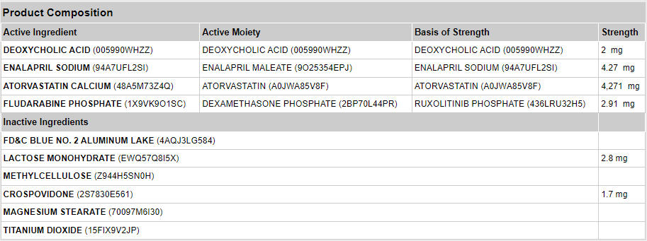

#### Active Ingredients

For each drug, all active ingredients, ingredient roles and strength must be provided.

**Figure 8 Structure for Active Ingredients Shown in the XML Code**

**Active Ingredient Role (<ingredient>)**

The code for the active ingredient role is selected from the CV (OID 6.39).

**Active Ingredient Strength (<quantity>)**

Strength information is required for all active ingredients. The ingredient strength is specified as a physical quantity using a numerator and a denominator.

**Numerator and Denominator (<numerator> and <denominator>)**

The numerator and denominator are composed of a value attribute and a unit attribute. The unit is selected from the CV (OID 6.15).

**Numeric value of strength (value attribute)**

Whole numbers must always be provided without spaces or commas in both English and French. Numbers containing decimals must always use a period in both English and French. The style sheet will render the numbers appropriately in each language.

When a range is required, there are two value attributes represented by a <low> element and a <high> element. See 2.5.3.1.2 for different representations of strength.

##### Active Ingredient Roles

All active ingredients in a manufactured product must be assigned a role, which is defined by how the basis of strength is calculated.

**Table 3 Active Ingredient Roles**

| **Code** | **Description** |
| --- | --- |
| ACTIB | The basis of strength is the active ingredient |
| ACTIM | The basis of strength is the active ingredient’s therapeutic moiety |
| ACTIR | The basis of strength is another reference substance[2] with the same active moiety |

**Figure 9 Active Ingredient with Ingredient Role ACTIB Shown in Rendered HTML and Supporting XML Code**

**Ingredient (<ingredientSubstance>) and active moiety (<activeMoiety>)**

The code and display name for the active ingredient are selected from the CV (OID 6.14).

**Ingredient Name (<ingredientSubstance> <name>) and (<activeMoiety> <name>)**

The name must match the display name.

**Figure 10 Active Ingredient with Ingredient Role ACTIM Shown in Rendered HTML and Supporting XML Code**

**Figure 11 Active Ingredient with Ingredient Role ACTIR Shown in Rendered HTML and Supporting XML Code**

**Reference substance (<asEquivalentSubstance> <definingSubstance>)1**

The code and display name for the active ingredient are selected from the CV (OID 6.14). For use with ACTIR only.

**Reference substance Name (<asEquivalentSubstance> <definingSubstance> <name>)**

The name must match the display name. For use with ACTIR only.

##### Active Ingredient Strength

The strength of an active ingredient is represented differently depending on the type of product. The following three examples show a solid, liquid and a range.

**Figure 12 Strength for a Solid Shown in Rendered HTML and Supporting XML Code**

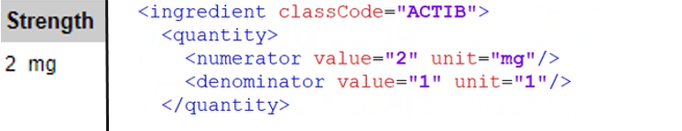

**Figure 13 Strength for a Solution Shown in Rendered HTML and Supporting XML Code**

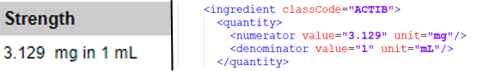

**Figure 14 Strength for a Range Shown in Rendered HTML and Supporting XML Code**

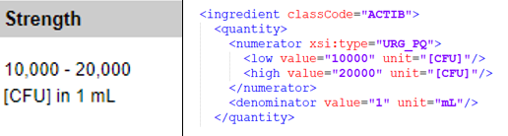

#### Inactive Ingredient

All inactive ingredients in a manufactured product should be listed in this section and have the assigned role of IACT. The inactive ingredients are built the same way as the active ingredients. The active moiety (<activeMoiety>) and reference substance (<asEquivalentSubstance>) do not apply for inactive ingredients.

**Amount (<quantity>)**

Strength is not required for inactive ingredients, however, if it is provided it will be published. The ingredient strength is specified as a physical quantity using a numerator and a denominator.

**Figure 15 Inactive Ingredients Shown in Rendered HTML and Supporting XML Code**

### Packaging Status

Information on all packaging configurations should be provided in this section, including those that are no longer available. The information in this section does not reflect availability on the Canadian market. Configurations should be listed in the order that they were introduced.

A package configuration is required for each manufactured product and may consist of a single package type (e.g., tablet in a bottle) or multiple package types (e.g., tablet in a blister in a box). Each packaging configuration exists within its own <asContent>.

#### Single Package Type

**Figure 16 Single Layer Packaging Configuration Shown in Rendered HTML and Supporting XML Code**

**Quantity within the package type (<quantity>)**

The quantity is required for each package type within a packaging configuration. The quantity is specified using a numerator and a denominator.

**Numerator and Denominator (<numerator> and <denominator>)**

The numerator and denominator are composed of a value attribute and a unit attribute. The unit is selected from the CV (OID 6.15). When there are no units (e.g., for a solid dosage form) “1” should be used.

**Package Type (<containerPackagedProduct>)**

This represents the structure of the packaging configuration that includes package identifier and package type.

**Package Identifier (<code>)**

The package identifier is an industry-defined value that is used to identify this package type and distinguishes it from other package types.

**Package Description and Name (<formCode>)**

The code and display name for the package type are selected from the CV (OID 6.32).

**Date Introduced (<effectiveTime><low>)**

The date introduced should reflect the date upon which the NOC or Drug Identification Number (DIN) was issued that provided authorization for this packaging configuration. Where the packaging configuration was introduced via Annual Notification, the date of implementation should be used.

The date format is YYYYMMDD. When this date is not known, the <effectiveTime> and the low attribute should be omitted.

**Date Removed (<effectiveTime><high>)**

The Date Removed should reflect the end of a packaging configuration’s lifecycle. This date is not intended to show a temporary removal from use and should be considered final.

The date format is YYYYMMDD. The <effectiveTime> and the high attribute should be omitted until required.

#### Multiple Package Types

For packaging configurations that contain multiple package types (e.g., blisters in a box), multiple <asContent> are required.

The outermost <asContent> represents the package type that is in contact with the product (e.g., the blister that contains the tablets). Further package types within the packaging configuration are nested within their own <asContent> (e.g., the box that contains the blisters).

**Figure 17 Multi-layer Packaging Configuration Shown in Rendered HTML and Supporting XML Code**

### Product Status

The product status is intended to provide a high-level summary of the lifecycle of each manufactured product. As such, the RA type, control number and Date of Initial Authorization should reflect the very first time this manufactured product was authorized in Canada. This information should not change over the lifecycle of the composition, regardless of ownership or the assignment of a new DIN.

**Figure 18 Product Status Shown in Rendered HTML and Supporting XML Code**

**Control Number (<approval> <id>)**

This is the 6-digit control number under which this manufactured product was first authorized for use in Canada. This control number will remain the same throughout the life cycle of the manufactured product, even if there is a change of ownership.

**Regulatory Activity Type (<approval><code>)**

This is the regulatory activity type under which this product was first authorized in Canada. The code and display name for the regulatory activity type are selected from the CV (OID 6.37).

**Approval Authority (<territory><code>)**

This is the approval authority under which the product was initially authorized. The value selected is always “CAN”, however this content is not rendered by the style sheet. The code and display name for the regulatory activity type are selected from the CV (OID 6.17).

**Date First Authorized in Canada (<marketingAct><effectiveTime><low>)**

This date is defined in the PM Guidance. Different manufactured products may be authorized at different times, and therefore may have different dates. The date format is YYYYMMDD. When this date is not known, the <effectiveTime> and the low attribute should be omitted. The date should be added prior to submitting the final XML PM.

**Date of Cancellation (<marketingAct><effectiveTime><high>)**

This date is defined in the PM Guidance. Different product may be cancelled at different times and may therefore have different dates. The product should remain listed even after cancellation if any other manufactured products are still active. The date format is YYYYMMDD. When this date is not known, the <effectiveTime> and the high attribute should be omitted. The date should be added to the XML PM the next time it is submitted after the cancellation.

### Product Characteristics

Product characteristics include physical characteristics, regulatory and standard information about each manufactured product. There are 10 product characteristics (<characteristic>) for each product. Not all characteristics will apply to all products, however all that do apply should be provided.

Product characteristics are set up to allow for specific types of data to be provided. Some characteristics rely on CVs, some allow for text to be added to the CV, and some allow for multiple entries for a characteristic to be listed.

**Table 4 Product Characteristic Information**

|  |  |  |  |  |
| --- | --- | --- | --- | --- |
| **Characteristic** | **xsi:type** | **OID** | **Original Text** | **Multiple Occurrences Supported** |
| Product Type | CV | 6.53 |  |  |
| Colour | CV | 6.24 | Yes | Yes |
| Shape | CV | 6.25 | Yes | Yes |
| Size | PQ | 6.15 |  |  |
| Score | CV | 6.4 |  |  |
| Imprint | ST | N/A |  |  |
| Flavour | CV | 6.26 | Yes | Yes |
| Pharmaceutical Standard | CV | 6.5 |  | Yes |
| Schedule | CV | 6.2 |  | Yes |
| Therapeutic Class | CV | 6.6 |  | Yes |

CV (Coded Value): Coded data, specifying a code, OID and display name.

PQ (Physical Quantity): Quantity, specifying a value and a unit of measure.

ST (Character String): Free text used for imprint.

**Figure 19 Product Characteristic using a Coded Value Shown in Rendered HTML and Supporting XML Code**

**Product Characteristic Name (<characteristic><code>)**

The code and display name for the product characteristics are selected from the CV (OID 6.23).

**Product Characteristic Value (<characteristic><value>)**

See **Table 4** for xsi:type and applicable CVs.

**Original Text (<originalText>)**

Original text is used to further refine the selected characteristics. The length of this text should be kept to a minimum.

**Figure 20 Product Characteristic using a Physical Quantity Shown in Rendered HTML and Supporting XML Code**

**Product Characteristic Unit (<characteristic><value>)**

The size is composed of a value attribute and a unit attribute. The unit is selected from the CV (OID 6.15).

**Figure 21 Product Characteristic using a Character String Shown in Rendered HTML and Supporting XML Code**

**Product Characteristic Unit (<characteristic><value>)**

The imprint <value> is provided as free text.

### Route of Administration

**Figure 22 Route of Administration Shown in Rendered HTML and Supporting XML Code**

**Route of Administration (<routeCode>)**

The code and display name for the route of administration are selected from the CV (OID 6.7).

### Multi-Part Products

A multi-part product is any product that has multiple formulations. This concept enables the product details information to be captured for each part of the product as well as the overall product.

A multi-part product could have a single DIN (e.g., a multiphasic birth control pill where there are different parts and only the overall product has a DIN) or multiple DINs (e.g., powder for solution with a diluent where each part has its own DIN and the overall product has a DIN). Multi-part products are not considered kits as defined in Directive: Assignment of Drug Identification Numbers for Drug Products in Kits, 1997.

Multi-part products are coded/created/built similarly to regular products, with a few exceptions to the structure, as follows.

#### The Product

The Product Details information is provided for the multi-part product and each of its parts.

The multi-part products follow the same overall structure as a regular product, and will include most of the product information, and the product status and packaging status. The route of administration, ingredients and the product characteristics are not included in the multi-part product since those apply to the individual parts only. The manufactured dosage form for should always be “Multi-part product” (OID 6.3).

The multi-part product will include a summary of the packaging information from each of the parts in a table called “Quantity of Parts”. The information displayed comes from the data provided in each of the parts.

**Figure 23 Multi-Part Product Shown in Rendered HTML and Supporting XML Code**

#### The Parts

Each part of a multi-part product will contain all the product detail information applicable to that part. The parts also follow similar overall structure as a regular product, except that they are contained within <part> and <partProduct> elements.

**Figure 24 Part of a Multi-Part Product Shown in Rendered HTML and Supporting XML Code**

**Total Product Quantity (<part><quantity>)**

This is the total quantity of each part.

**Package Quantity (<part><partProduct><asContent>)**

This is a summary of the package description of each part. This is handled in the same way as for a single product (see 2.4.4)

## Product Monograph Content

The XML PM follows the PM Guidance Document and Master Template. To accommodate all requirements, the XML PM has seven major sections. Major sections may contain sections and subsections, which further organizes content. Text is allowed to directly follow only three of the major section headings, the rest must have a section or subsection before any text can be added.

**Table 5 Requirements for the Major Section Headings**

|  |  |  |
| --- | --- | --- |
| **Major Section Heading** | **Inclusion in XML PM** | **What is allowed to follow** |
| TITLE PAGE | Required | Sections and Subsections |
| NOTICE OF COMPLIANCE WITH CONDITIONS | Optional* | Text |
| RECENT MAJOR LABEL CHANGES | Required | Text |
| BIOSIMILAR BIOLOGIC DRUG | Optional* | Text |
| PART I: HEALTH PROFESSIONAL INFORMATION | Required | Sections and Subsections |
| PART II: SCIENTIFIC INFORMATION | Required | Sections and Subsections |
| PATIENT MEDICATION INFORMATION | Required | Sections and Subsections |

*If not applicable, the whole major section should be omitted

**Figure 25 Section or Subsection Following a Major Section Heading Shown in Rendered HTML and Supporting XML Code (<component><section><component>)**

**Figure 26 Text Following a Major Section Heading Shown in Rendered HTML and Supporting XML Code (<component><section><text>)**

All major section headings, section headings and subsection headings are managed as controlled vocabularies and must not be modified. The code and display name for the section headings are selected from the CV (OID 6.63). The content in the title element is used to display the section heading in the HTML rendered PM. The display name and the title must match except for the following cases:

1. Clinical Group (see Section 2.6.4.1)
2. Unassigned (see Section 2.6.4.2)
3. Patient Medication Information (PMI) (see Section 2.6.5)

### Title Page

The title page is the first major section in the narrative section of the XML PM as outlined in the PM Guidance. There are six sections within the title page.

**Title Area (<text><paragraph>)**

This area shows the standard information about the product that is required on all PMs.

**Figure 27 The Top Section of the Title Page Shown in Rendered HTML and Supporting XML Code**

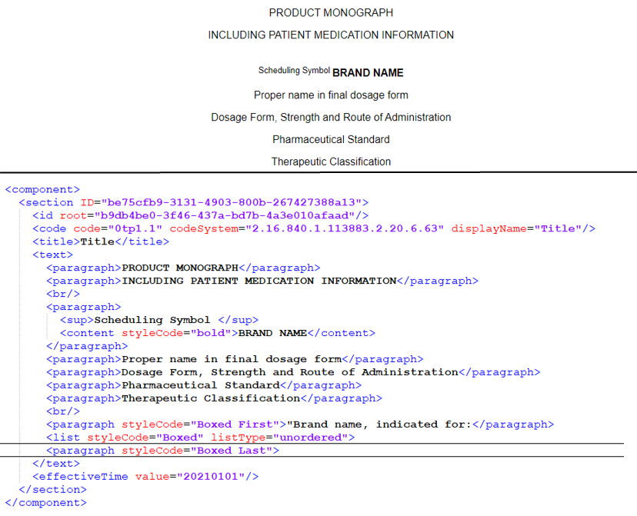

**Company Name and Address (<text><paragraph>)**

The information required is outlined in the PM Guidance.

A separate <component> element is required for each company. A single <paragraph> element should be used all the company information. Within that <paragraph> element a <br/> element can be used to separate each piece of information (e.g., company name, street, city, etc.).

Use the Canada Post abbreviations for provinces and territories, without any periods. The postal code may be placed on the same line as the province, with two spaces between them. Do not put a comma between the province and the postal code.

**Figure 28** **Company Information on the Title Page Shown in Rendered HTML and Supporting XML Code**

**Title Page Dates (<text><paragraph>)**

Dates formatting is YYYY-MM-DD. The style sheet renders the numeric date as text. When a date is not known or not applicable, the <text> and <paragraph> should be omitted.

**Figure 29 Date First Authorized in Canada on the Title Page Shown in Rendered HTML and Supporting XML Code**

**Control Number (<text><paragraph>)**

The control number should be provided when known. When it is not known, the <text> and <paragraph> should be omitted.

**Figure 30** **Control Number on the Title Page Shown in Rendered HTML and Supporting XML Code**

**Footer (<text><paragraph>)**

The footer is optional. If included, it should be inline with the PM Guidance.

**Figure 31 A Footer on the Title Page Shown in Rendered HTML and Supporting XML Code**

### Notice of Compliance with Conditions and Biosimilar Biologic Drug

The standard statements should be provided when required as per the PM Guidance. These sections can be omitted when not required.

**Figure 32 The Notice of Compliance with Conditions Statement Shown in Rendered HTML and Supporting XML Code**

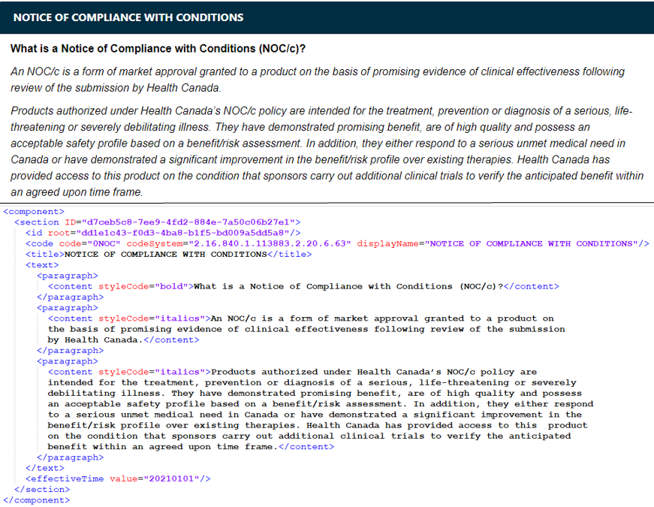

### Recent Major Label Changes

When changes are required in the Recent Major Label Changes (RMLC) section, as per the PM Guidance, a table format should be used. A hyperlink to the changed section is to be provided. The date format is MM/YYYY.

**Figure 33 The RMLC Table Shown in Rendered HTML and Supporting XML Code**

As per the PM Guidance Document, a vertical line in the body of the PM is required to indicate changes listed in the RMLC section. A style code is added to the text to accomplish this.

**Figure 34 The Vertical Line Annotation Shown in Rendered HTML and Supporting XML Code**

When no changes are required in the RMLC section, the statement “None at time of the most recent authorization” should be added.

**Figure 35 The RMLC with no Changes Required Shown in Rendered HTML and Supporting XML Code**

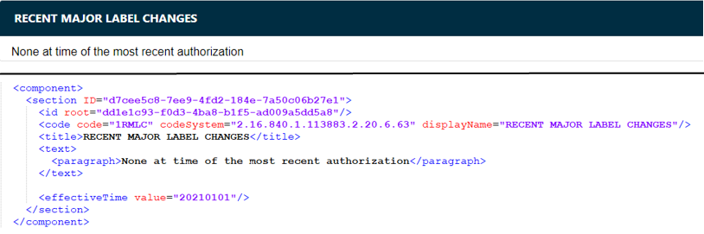

### Part 1: Health Professional Information and Part II: Scientific Information

The content should be provided as per the PM Guidance. The sub-sections can be omitted when not required, however the numbering must be maintained to comply with the CV.

#### Clinical Group

Sponsors should use “Clinical Group” to insert organizational headings in section 14.1 Clinical Trial Design and Results. The code and display name for the clinical group (“CG”) are selected from the CV (OID 6.63). The <title> should be modified as per the PM Guidance.

**Figure 36 A Clinical Group Shown in Rendered HTML and Supporting XML Code**

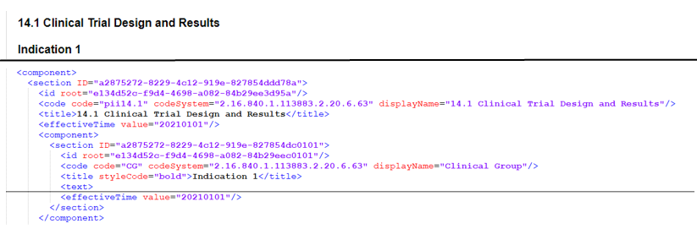

#### Unassigned

Unassigned is a mechanism used to add an emerging or product specific requirements that are not covered by the current Master Template. The expectation is that this would be used as an interim measure to address a gap pending an update to the Master Template. Any new subsections should be added after the existing Master Template subsections to maintain the numbering.

The code and display name for unassigned (“UA”) is selected from the CV (OID 6.63). The <title> should be modified to reflect the new section. The use of Unassigned results in an additional entry in the Table of Contents. Unassigned must not be used for creating sub-sections for content that is already in the Master Template (e.g. Section 7, Cardiovascular).

**Figure 37 Use of Unassigned Shown in Rendered HTML and Supporting XML Code**

### Patient Medication Information

The content should be provided as per the PM Guidance. The code and display name for the PMI section headings are selected from the CV (OID 6.63). The code and display names must match the CV, however the <title> should be modified where there is reference to Brand name.

**Figure 38 Modifications in Title for PMI Shown in Rendered HTML and Supporting XML Code**

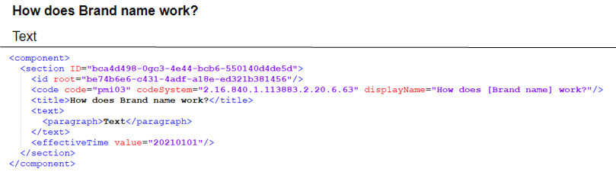

## Additional Concepts

### Format

It is highly recommended that sponsors review the rendered XML PM prior to submitting to ensure that the content is in line with the PM Guidance and Master Template.

The style sheet controls the majority of the formatting, including bolding and spacing based on the PM Master Template and its related CV.

The following recommendations should be applied throughout the XML PM where formatting is not covered by the style sheet.

• Formatting should be in line with the PM Master Template

• Underlining should only be used for hyperlinks

• Use of bold and italics should be limited

• Limit the use of line breaks to avoid unnecessary white space

### Images

The XML PM uses .jpg files to render images. All images must be defined in order to be used in the XML PM. Each distinct image is assigned a unique ID, which allows an image to be used multiple times throughout the XML PM. The .jpg files should be placed in the same folder as the .xml file

The style sheet displays all images as is without modification. Therefore, images should use a sufficient resolution to be clear and readable across different screen sizes and devices.

When an image contains language specific text, separate image files are required for each language (English and French). For example, when text is included within the image, the image in the French XML PM should have French text. When an image can be used for both the English and French XML PM, it should only be provided once.

**Figure 39 Image Definition Supporting XML Code**

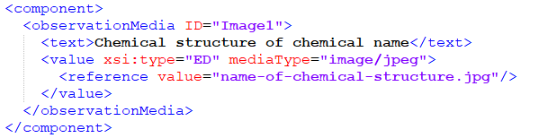

**Definition of image (<observationMedia> ID attribute)**

This ID is used when defining an image. The identification should be assigned a unique value within the XML PM. Once an image has been defined, it must be referenced where the image is to be shown.

**Alternative Text (<text>)**

All images require text alternatives, also known as Alt Text. This should be a meaningful description of the image used for both accessibility purposes (e.g., screen readers for sight impairment) and when an image cannot be rendered due to technical issues (e.g., displays text instead of image). This description should be sufficiently detailed to enable the reader a mental picture of the image. There are many references and guidelines available online, e.g., [W3C’s Image Tutorials](https://www.w3.org/WAI/tutorials/images/) provide guidance to write Alt Text effectively. The alternative text is not visible in the rendered XML PM.

**Figure 40 An Image Shown in Rendered HTML and Supporting XML Code**

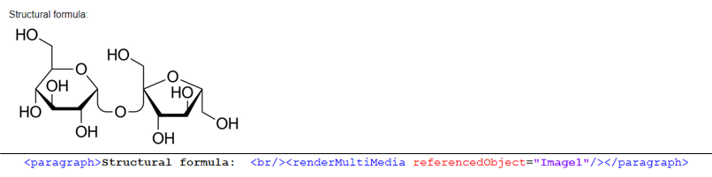

**Naming of .jpg file (<reference> value attribute)**

The .jpg file names must be unique within a PM in order to avoid naming conflicts with other images. This applies to both the English and French versions. This allows the .xml file to reference the correct .jpg file.

The image files should be named with the following best practices:

* Lowercase only (as per eCTD specification)
* Should be kept short
* Separate words with hyphens (no spaces)
* Accented characters are not permitted

### Tables

Tables are used throughout the XML PM. There are several items to consider to ensure that the data within these tables is rendered correctly regardless of the screen size and is accessible.

**Figure 41 Table Shown in Rendered HTML and Supporting XML Code**

**Table Identification (<table> ID attribute)**

This ID is used when creating a hyperlink to the table. The identification should be assigned a unique value within the XML PM.

**Table border and gridlines (<table> rules and frame attributes)**

This defines the border and the gridlines of the table. Tables should be defined with rules=“all” frame="border".

**Table Title (<caption>)**

A caption functions like a heading for a table. Most accessibility tools identify the content of these captions. Captions help users to understand what the table is about and decide if they want to read it. All tables in the PM must have a caption, with the RMLC being the only exception.

**Table Headers (<thead>)**

Table Header is used to group header content.

**Table Rows (<tr>)**

The <tr> defines a table row, that contains one or more <th> or <td> elements

**Header Cells (<th>)**

Headers cells defines a header cell. This is important to accessibility tools to identify the contents of the column.

**Table Body (<tbody>)**

Table Body are used to group the table data content.

**Data Cells (<td>)**

Data cells defines a data cell.

#### Table Formatting

The style sheet has been designed to ensure consistent display of the PM on different devices and screen sizes. Sponsors should not add formatting that will override the style sheet.

The style sheet controls the following table formatting characteristics:

* Captions (bold and centered)
* Border colour (black)
* Header row shading (grey)
* Header text (bold and center aligned)
* Table width (100%)

#### Cell Shading

Cell shading can be used to identify cells where a value is not applicable or not expected. To shade cells, use the styleCode attribute “table-secondary”.

**Figure 42 Cell Shading within a Table Shown in Rendered HTML and Supporting XML Code**

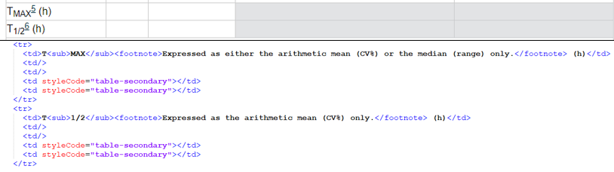

### Hyperlinks

There are two types of hyperlinks used in the XML PM: external and internal, and both are underlined by the style sheet.

**Hyperlink (<linkHtml> href attribute)**

This is used to place a hyperlink within the XML PM.

#### External Hyperlinks

External hyperlinks are used to link to a website. The URL does not display on the rendering – only the human readable name of the link (e.g., “Health Canada website”) is shown.

**Figure 43 An External Hyperlink Shown in Rendered HTML and Supporting XML Code**

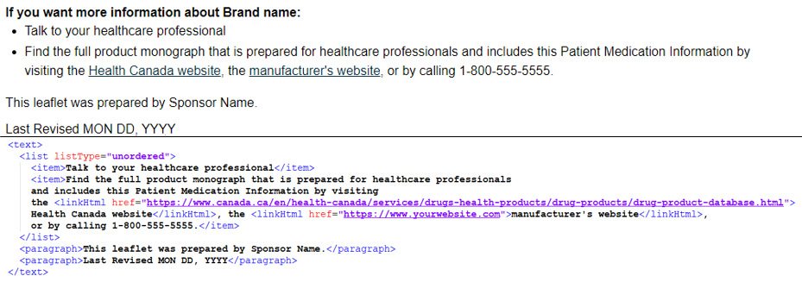

#### Internal Hyperlinks

Internal hyperlinks are used to link to other content in the PM which is indicated by an href attribute that starts with ‘#’ followed by the ID attribute. The ID attribute must be assigned a unique value within the XML PM to ensure it functions correctly. Internal hyperlinks can be made to a section or to content within a section.

To link to a section within the XML PM, the ID or the <id> root> from that section is referenced.

**Figure 44 A Hyperlink to a Section Shown in the Rendered HTML and the Supporting XML Code**

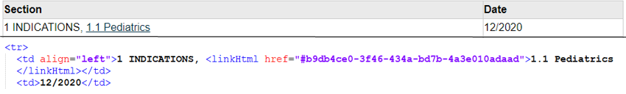

To link to specific content within a section, a hyperlink needs to be first defined where it will point to using an ID attribute. This can be linked to <paragraph>, <table>, <list>, <content>, or <renderMultimedia>. The ID attribute should be assigned a unique value within the XML PM. The unique ID attribute can then be hyperlinked to anywhere in the XML PM.

**Figure 45 A Hyperlink to content within a Section Shown in the Rendered HTML and the Supporting XML Code**

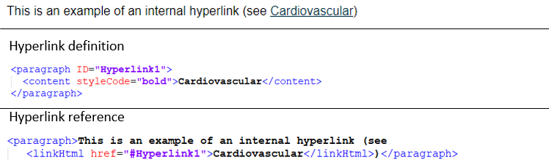

### Boxes statements

Boxed statements are required, to draw attention to specific safety related information. These statements should only be boxed using the styleCode attribute. Boxed statements using tables causes accessibility issues and should not be used.

**Figure 46 Boxed Text with a Single Text Style Shown in the Rendered HTML and the Supporting XML Code**

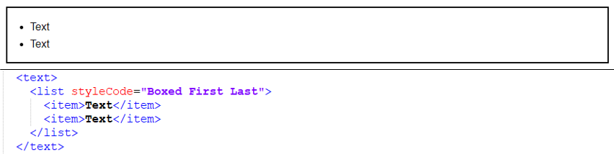

In this sample a single styleCode attribute is used with a value of “Boxed First Last”.

**Figure 47 Boxed Text with Multiple Text Style Shown in the Rendered HTML and the Supporting XML Code**

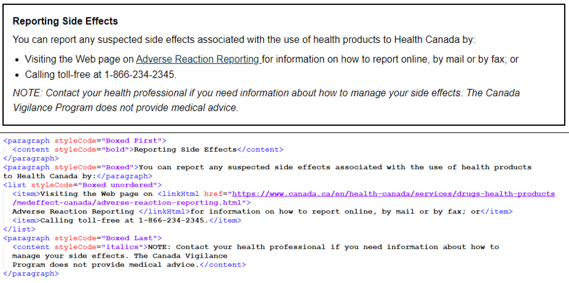

In this sample a multiple styleCode attributes are used. The first occurrence has a value of “Boxed First”, followed by occurrences of “Boxed”, and finishing with a value of “Boxed Last”.

### Footnotes

The style sheet automatically renders footnotes using numbers. Footnotes are defined using the <footnote> within the following: <paragraph>, <list><item>, and within tables in the <th> <td>.

**Figure 48 Footnotes Shown in the Rendered HTML and the Supporting XML Code**

**Footnote Identification (<footnote> ID attribute)**

This ID is used when creating a footnote. The identification should be assigned a unique value within the XML PM.

**Footnote content (<footnote>)**

The text of the footnote.

**Footnote Reference (<footnoteRef> IDREF attribute)**

The footnote reference allows the use of a previously defined footnote in a different location.

**Footnote Content Width (<colgroup> span attribute)**

When table footnotes are used, the <colgroup> span attribute should be set to the number of columns to use the full table width. This is important so that the footnotes run the width of the whole table instead of just one column.

### Special Characters

XML uses five symbols to mark how content is being used within the .xml document. When those symbols are part of the content, the use of escape characters is required to be a valid xml file.

|  |  |
| --- | --- |
| **Symbol** | **Escape character** |
| " | &quot; |
| ' | &apos; |
| < | &lt; |
| > | &gt; |
| & | &amp; |

**Table 6 Symbols and Associated Escape Characters**

**Figure 49 Escape Character Use Shown in the Rendered HTML and the Supporting XML Code**

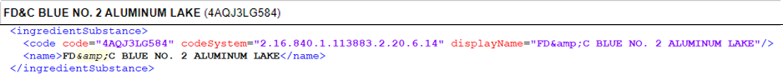

## Relationship of Unique Identifiers

**Figure 50 Relationship of Unique XML PM Identifiers to HC Unique Identifiers**

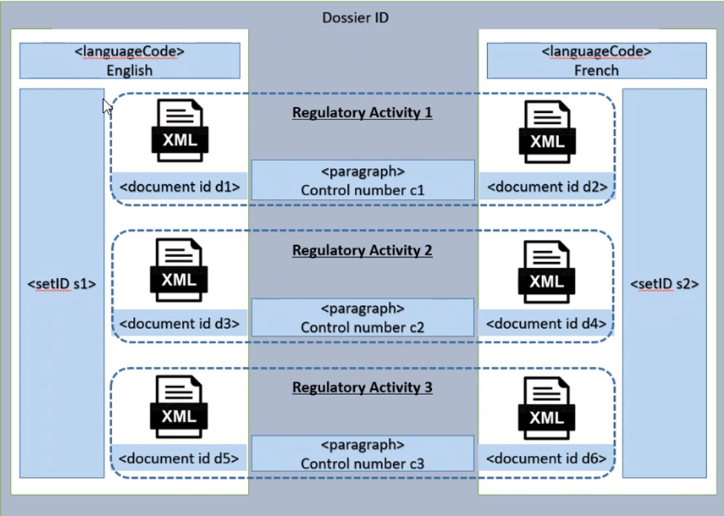

**Language Code <languageCode>:** This is what determines the language of the XML PM. The English and French XML PMs cannot be authored as one document. They must be provided as two separate, language specific XML PMs.

**Document ID (<id>):** For each regulatory activity there is a unique document ID for each language specific XML PM. The document ID doesn’t need to change for revisions made during that regulatory activity’s review process.

**Set ID <setId>:** Throughout the lifecycle of the product, the English and French XML PMs have their own unique setId. The setId links together all the XML PMs for a specific language over the lifecycle of the product.

The following tables show the relationship between the setID and documentID over the lifecycle of a single product for each language of the XML PM.

**Table 7 Relationship of English XML PM to the setID and Document ID in Relation to Regulatory Activities**

| **Regulatory Activity** | **setId - English** | **Document ID** |
| --- | --- | --- |
| 1 | d4c004d2-976d-4aec-8cdd-a71bdb11d4b1 | bd28a915-72c1-4c9b-95ec-f80140f9792e |
| 2 | e796df04-2fd5-4894-8b22-6234e96e77d2 |
| n+1 | 11d3fb08-035d-4b32-9d63-4d37dfad1685 |

**Table 8** **Relationship of English XML PM to the setID and Document ID in Relation to Regulatory Activities**

|  |  |  |
| --- | --- | --- |
| **Regulatory Activity** | **setId - French** | **Document ID** |
| 1 | c99b9224-f519-4e52-bdbe-1750a5b1a26e | 1262a4e6-bc34-413e-bbf4-a8ec3fb512e1 |
| 2 | 944364a1-0f76-44b3-b2f6-60cf61df8a1d |
| n+1 | aee16a81-8021-4058-86dc-154ba5b0516c |

# Validation

Validation of the XML PM is based on [published rules](https://www.canada.ca/en/health-canada/services/drugs-health-products/public-involvement-consultations/drug-products/structured-product-monograph/validation.html). The purpose of the validation rules is to help ensure sponsors provide a valid XML file (and associated images) to Health Canada, and to reduce errors and follow-up with Sponsors. Sponsors are encouraged to use a commercially available tool to validate their XML PM prior to filing to Health Canada.

Validation rules test for structure, properly formed files, correct use of controlled vocabulary and structure of the content. Rules are assigned a level of severity based on the level of impact to the XML PM should the rule not pass.

**Table 9 Descriptions of the Severity of Validation Rules**

|  |  |
| --- | --- |
| **Severity** | **Description** |
| **Error** | Critical compliance issue that will compromise usability of the XML PM. The issue must be corrected prior to (re-)submission of the Final XML PM. |
| **Warning** | Issue that may compromise usability of the XML PM but require further inspection. The issue may need to be corrected prior to (re-)submission of the Final XML PM. |
| **Information** | Issues that is not likely to compromise usability of the XML PM but may require further inspection. The issue may need to be corrected prior to (re-)submission of the Final XML PM. |

Health Canada validates each XML PM upon receipt. An XML PM Validation Report is emailed as a .pdf attachment to the contact listed on the Regulatory Transaction (RT) file provided in the eCTD transaction with the XML PM. This report will describe all error, warning, and information messages. The expectation is that all errors and applicable warnings are addressed prior to the submission of the final XML PM.

Assistance with validation and correction of errors and warnings is available from the [XML PM Team](mailto:xmlpm-pmxml@hc-sc.gc.ca).

# Guidance for Submitting the XML PM

Sponsors can only submit an XML PM as part of a RA that already includes the PM (new or update). XML PMs cannot be provided outside the context of a RA.

For generic products, it is recommended sponsors wait until the PM for the Canadian Reference Product (CRP)/Reference Product (RP) has converted to the XML PM to ensure the information in the product details section is aligned. If the generic product is converted to the XML PM ahead of the CRP/RP, revisions may be required once the CRP/RP does convert to ensure that the product details sections are aligned. This recommendation does not apply when the CRP/reference product is no longer marketed.

For products authorized under license agreements, the sponsor (i.e., licensee) should wait until the licensor’s PM has converted to the XML PM format. At minimum, the licensor’s PM is required to be following the Master Template before the licensee can convert to the XML PM.

Once an XML PM has been filed and approved for a given product, all subsequent RAs for PM updates must include an XML PM.

All image files must be re-submitted each time the .xml file is submitted. Failure to do so will result in a validation error and prevent the images from displaying in the XML PM.

* 1. Process for Regulatory Activities with XML PMs

The first XML PM filed for a product must be part of a regulatory activity that impacts the PM. XML PMs cannot be submitted for the first time for Administrative NDSs (excludes License Agreements). As Quality Notifiable Changes (BRDD only) do not impact PMs, they are out of scope.

For all RA types except Administrative NDSs, the XML PM is required at the time of filing in the first language only. The XML PM Certification Form is required in that sequence. Sponsors may include both languages at the time of filing if they choose.

Once the RA has been accepted into screening, the XML PM Validation Report will be sent to the sponsor. All errors and applicable warnings are expected to be corrected by the sponsor. However, a revised XML PM is not required during the review.

Sponsors are required to submit the final English and French XML PMs in the same transaction as the final French PM (in PDF) - within 20 days of NOC, NOL or DIN issuance. The XML PM validation report will be sent to the sponsor once the French PDF has been posted to the DPD Online. These final XML PMs are expected to have no errors or warnings. If there are any outstanding errors, sponsors are required to revise the XML PMs accordingly. The English and French XML PM and with the French PM (PDF) should be resubmitted in a subsequent sequence.

**Figure 51 Process flow for RAs containing XML PM (excludes Admin NDSs)**

For an Administrative NDS, the XML PM is required at the time of filing in both official languages. The XML PM Validation report will be sent to the sponsor once the NOC has been issued. Sponsors are required to revise the XML PMs to correct any errors or applicable warnings. Both the XML PM and the associated PDF versions, in English and French must be resubmitted. Please see Figure 55 in Appendix C for a graphic representation of this process.

**Figure 52 Process flow for Admin NDS containing XML PM**

## Setting up the XML PM in an eCTD sequence

The XML PM should be provided in Module 1, section m1-3-1-product-monograph of an eCTD sequence without any node extensions or subfolders. The XML PM Certification Form should be provided in Module 1, m1-2-3-certification-and-attestation-forms.

The first time an XML PM is submitted, the operation attribute NEW should be used for the .xml and .jpg files. The REPLACE value should be used when the files are provided again in a subsequent transaction.

File names for the .xml and .jpg files should not be changed when preparing the eCTD sequence. The file names should conform to XML PM specifications to avoid impact on the validation and viewing of the XML PM.

Sponsors are required to provide the eCTD language attribute on the eCTD node for each .xml file (e.g. xml:lang = “en”). The language attribute is not required for image files. The English and French XML PMs should be provided in the same sequence.

Sponsors are expected to review their XML PM in html format before filing to Health Canada to ensure there are no content or formatting issues.

# Appendices

## Appendix A – Acronyms

|  |  |
| --- | --- |
| ANDS | Abbreviated New Drug Submission |
| ATC | Anatomical Therapeutic Chemical |
| BRDD | Biologic and Radiopharmaceutical Drugs Directorate |
| CRP | Canadian Reference Product |
| CSS | Cascading Style Sheet |
| CSV | Comma Separated Values |
| CV | Controlled Vocabulary |
| DIN | Drug Identification Number |
| DPD | Drug Product Database |
| eCTD | Electronic Common Technical Document |
| EUNDS | Extraordinary Use New Drug Submission |
| EUSNDS | Supplement to an Extraordinary Use New Drug Submission |
| FDA | Food and Drug Administration |
| GSRS | Global Substance Registration System |
| GUID | Globally Unique Identifier |
| HC | Health Canada |
| HL7 | Health Level Seven |
| HPFB | Health Products and Food Branch |
| HTML | HyperText Markup Language |
| IDMP | Identification of Medicinal Products |
| ISO | International Organization for Standardization |
| NDS | New Drug Submission |
| NOC | Notice of Compliance |
| NOC/c | Notice of Compliance with conditions |
| NOL | No Objection Letter |
| OID | Object Identifier |
| PDF | Portable Document Format |
| PM | Product Monograph |
| RA | Regulatory Activity |
| RMLC | Recent Major Label Changes |
| RP | Reference Product |
| SANDS | Supplement to an Abbreviated New Drug Submission |
| SNDS | Supplement to a New Drug Submission |
| SPL | Structured Product Labelling |
| UCUM | Unified Code for Units of Measure |
| UNII | Unique Ingredient Identifier |
| US | United States |
| WAI | Web Accessibility Initiative |
| W3C | World Wide Web Consortium’s |
| WCAG | Web Content Accessibility Guidelines |
| WHO | World Health Organization |
| XML | Extensible Markup Language |

## Appendix B - Terms

**Accessibility**

The provision of health information to Canadians through the proactive identification, removal and prevention of barriers to accessibility.

**Attributes**

The XML attribute is a part of an XML element. The addition of attribute in XML element gives more precise properties of the element.

**Elements**

The XML elements are the basic building block of the XML document. It is used as a container to define text elements, attributes, media objects etc.

**Extensible Markup Language (XML)**

XML is a text-based markup language used to encode electronic documents in a structured format that is machine-readable. XML is used as a common format to facilitate the interchange of data over the Internet.

**Globally Unique Identifier (GUID)**

A GUID is a unique number that is used as an identifier. GUID’s are used in naming XML PM files and as unique identifiers within XML PM files.

**Rendering**

A means of displaying the XML content in a display that is easy to read and compatible with accessibility tools. Rendering of the XML PM files is performed using a HC defined style sheet.

**Sponsor-defined value**

These are values where HC does not provide any rules or requirements and are therefore left to the sponsor to manage (e.g., version number).

**Structured Product Labeling (SPL)**

SPL is a document markup standard approved by Health Level Seven (HL7) and adopted by FDA as a mechanism for exchanging product and facility information. Health Canada is adopting the SPL for the XML PM. The SPL Schema is a set of rules describing what data is permitted in the XML PM.

**Style sheet**

The XML PM style sheet defines layout and formatting of the XML PM content will be made available in a human readable format. XML PM style sheet is based on the World Wide Web Consortium’s (W3C) Cascading Style Sheet (CSS) standard specification and the Government of Canada’s Aurora Design System.

**Validation**

XML PMs are being validated against pre-specified set of rules. Each XML PM is validated upon receipt. The validation process ensures the XML PM meets the established requirements prescribed in the SPL schema and the Health Canada validation rules.

**World Wide Web Consortium (W3C)** is an international community where Member organizations, a full-time staff, and the public work together to develop Web standards (e.g., HTML, CSS, WCAG) <https://www.w3.org/Consortium/>

**Web Accessibility Initiative (WAI)** develops standards and support materials to help you understand and implement accessibility <https://www.w3.org/WAI/>

**Web Content Accessibility Guidelines (WCAG)** is developed through the W3C process in cooperation with individuals and organizations around the world, with a goal of providing a single shared standard for web content accessibility that meets the needs of individuals, organizations, and governments internationally. <https://www.w3.org/TR/WCAG20/>

## Appendix – Process Flows

**Figure 53 Process Flow to Find the Correct Name and Code for Active and Ingredients**

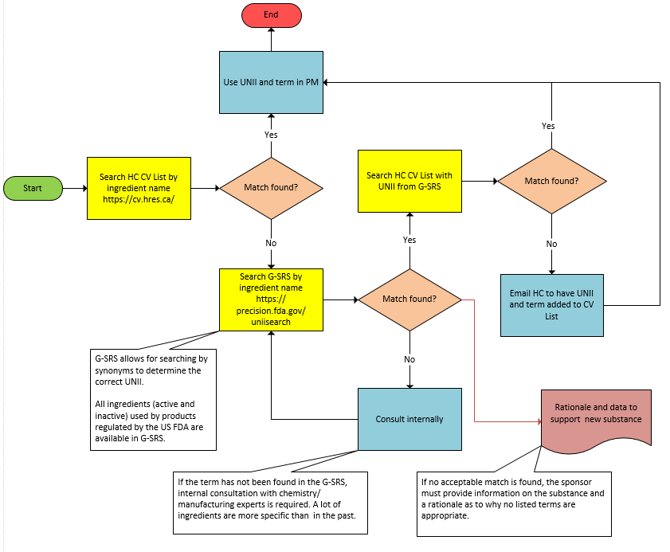

1. An account is required, but access is free
2. This is not the Canadian Reference Product